**Enterprise Resource Planning**

*Of*

**ZAB**

**Training User Manual**

**(SV–12.3.0 | MV–1.0.0)**

**For**

**ASIATIC GROUP**

**Production (Store Requisition)**

**Index**

|  |  |
| --- | --- |
| **About** | **Page No.** |
| **Production Part** | |
| * Store Requisition (Batch) | **08** |
| * Issue For Production | **11** |
| * Store Requisition (Bulk) | **11** |
| * Inspection Finished Goods | **11** |

**Production Part**

# Store Requisition (Batch)

|  |  |
| --- | --- |
| **Step 1** | Main Menu (Home Icon) **> Production >**  Store Requisition (Batch) |
| **Step 2** | Choose the Batch Number & Click **Show** |
| **Step 3** | Click **Chemical** for Requisition of Chemical Items |
| **Step 4** | Click **Fabric** for Requisition of Fabric Items |

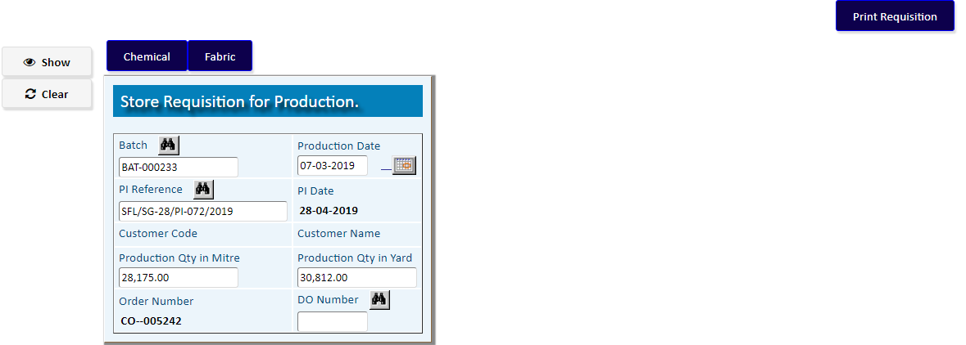

Click **Chemical** for Requisition of Chemical Items

Requisition of Chemical Items

|  |  |
| --- | --- |
| **Step 1** | Choose the **Process Name** & click **Add** |
| **Step 2** | A new TO of Chemical Requisition will be added |
| **Step 3** | Click **Select Item For Requisition** for Add Chemical Items |

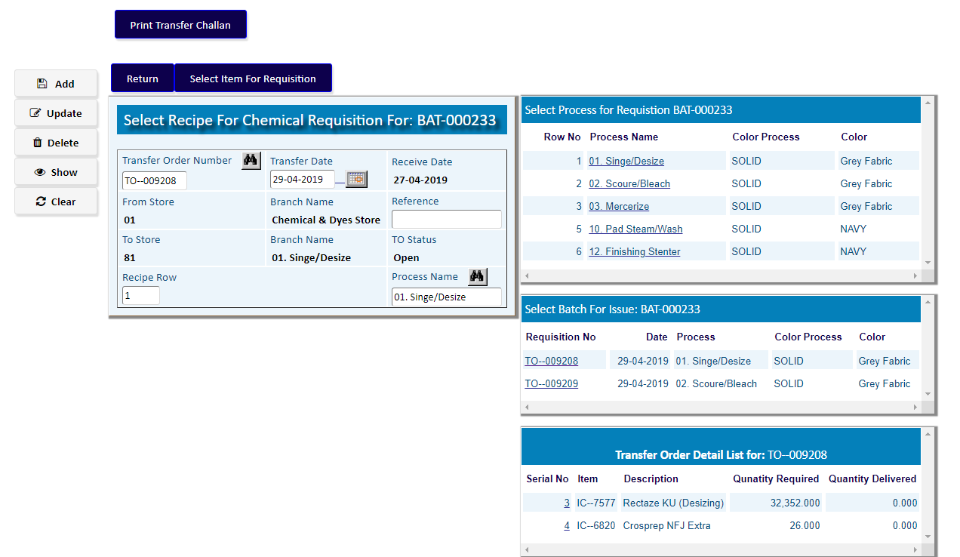

Click **Select Item for Requisition** for Add Chemical Items

Add Chemical Items with Item Code & Quantity Required

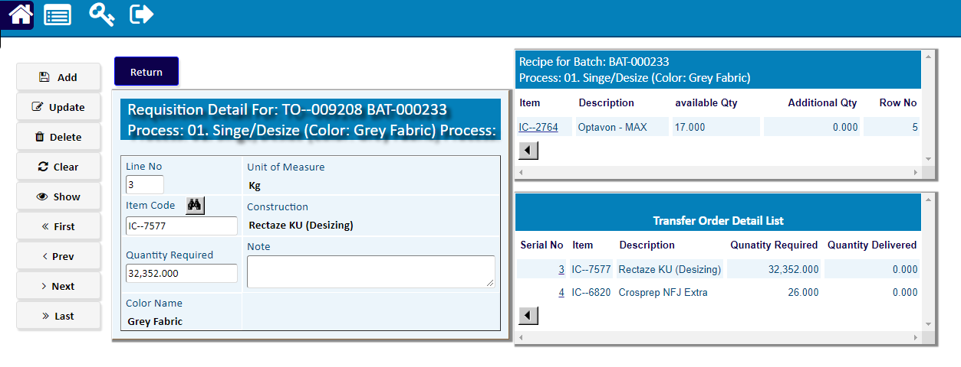

After adding Chemical Items, Click **Return**

Requisition of Fabric Items

|  |  |
| --- | --- |
| **Step 1** | Choose the **Process Name** & click **Add** |
| **Step 2** | A new TO of Fabric Requisition will be added |
| **Step 3** | Click **Select Item For Requisition** for Add Fabric Items |

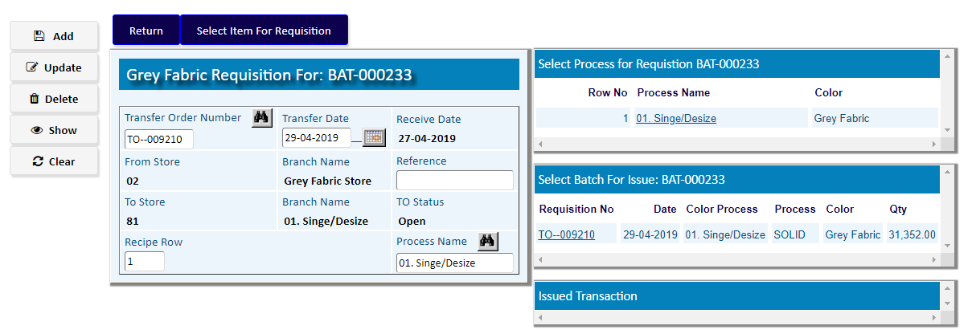

Click **Select Item for Requisition** for Add Fabric Items

Add Fabric Items with Item Code & Quantity Required

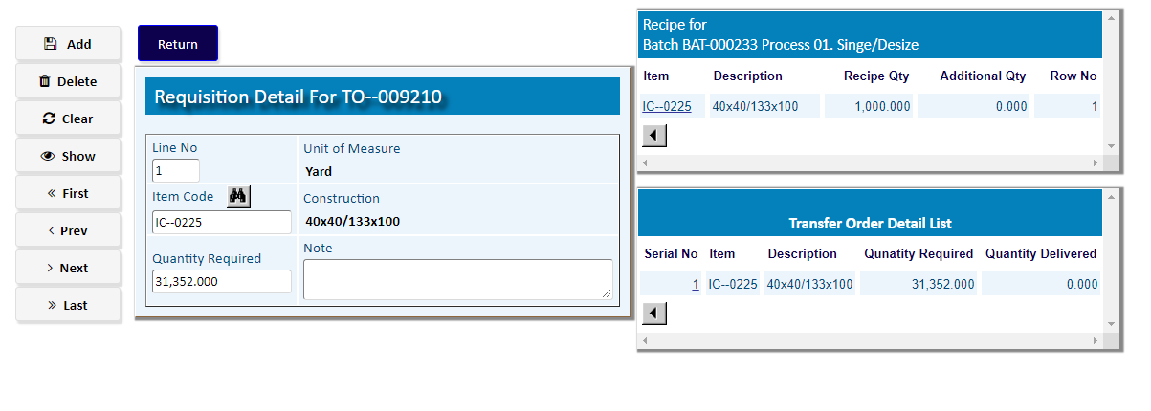

After adding Fabric Items, Click **Return**

# Issue For Production

|  |  |
| --- | --- |
| **Step 1** | Main Menu (Home Icon) **> Production >**  Issue For Production |
| **Step 2** | Choose the Batch Number & Click **Show** |
| **Step 3** | Click **Deatil** to issue the materials |

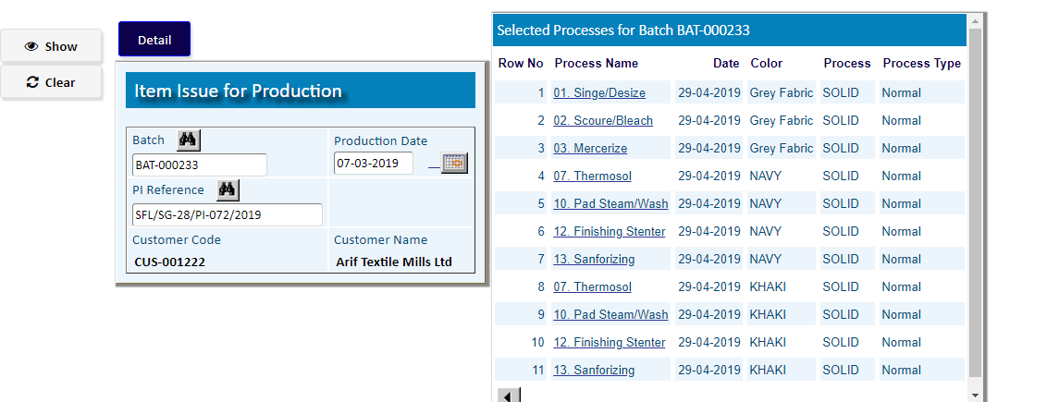

|  |  |
| --- | --- |
| **Step 1** | Select a Process Name from Side list |
| **Step 2** | Click **Issue Material** to issue the materials for that Process |

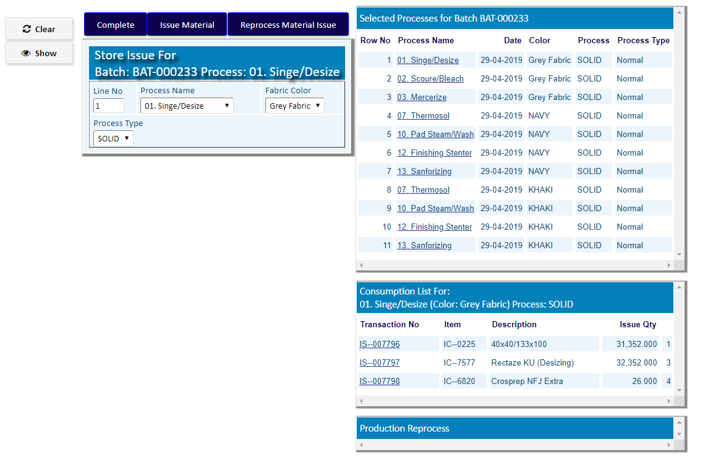

After adding Materials click **Complete**

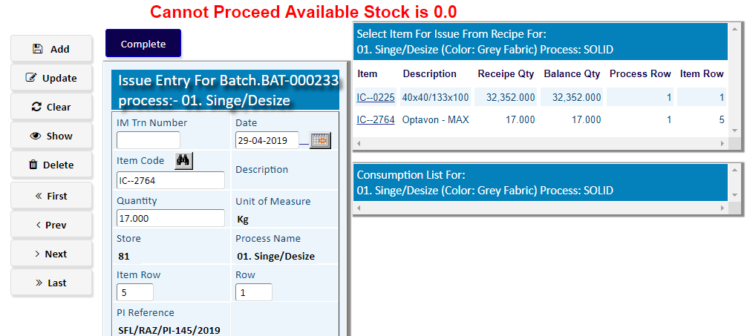

Here Stock of materials is not available.

**Whenever the Stock of materials is not available,**

**You have to go the option**

[**Store Requisition (Bulk)**](http://localhost:5080/zab/login?screen=moreqheaderprod&option=Store+Requisition+%28Bulk%29&menuname=mo)

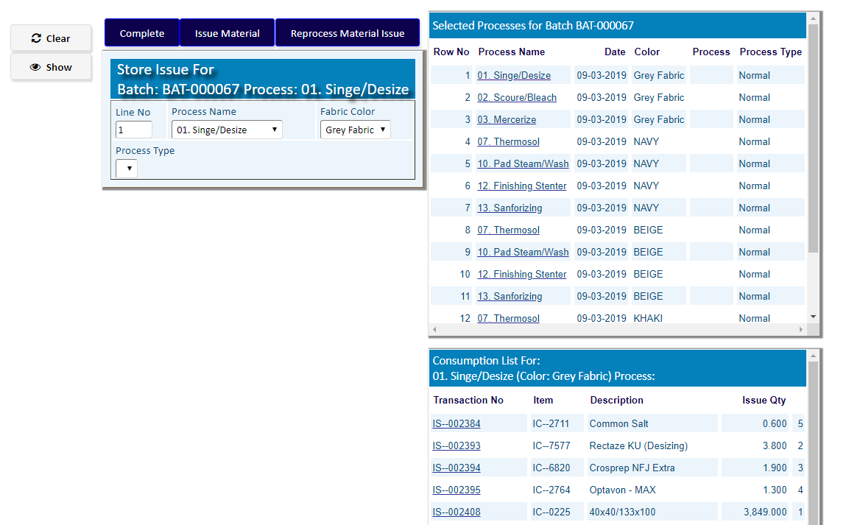

**If stock is available, click complete > complete after adding Materials for all Processes of Production**

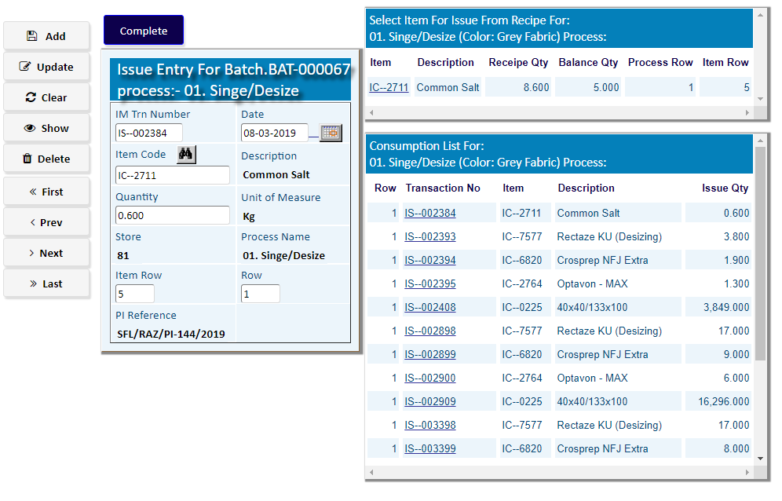

# Store Requisition (Bulk)

|  |  |
| --- | --- |
| **Step 1** | Main Menu (Home Icon) **> Production >**  Store Requisition (Bulk) |
| **Step 2** | Choose **From Store 01 ,** department & then click **Add** |
| **Step 3** | Click **Detail** to add requisition Items |

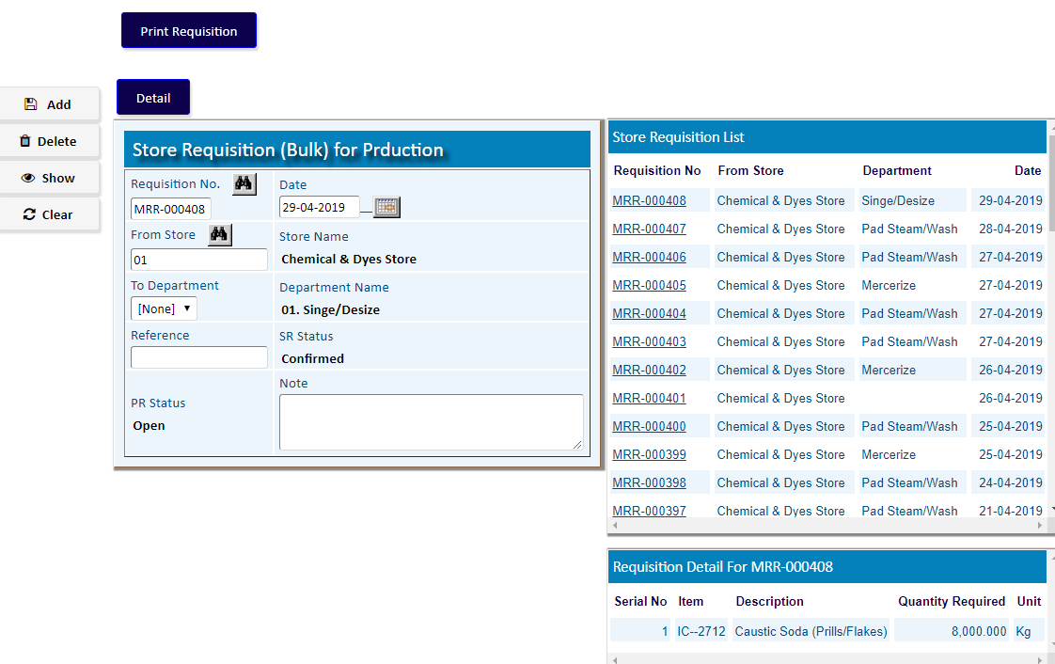

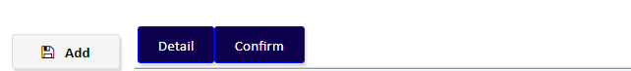

Click **Detail** to add requisition Items

1. Add Items with Item Code & Required Qty
2. Add more Items if Required
3. Click **Return**

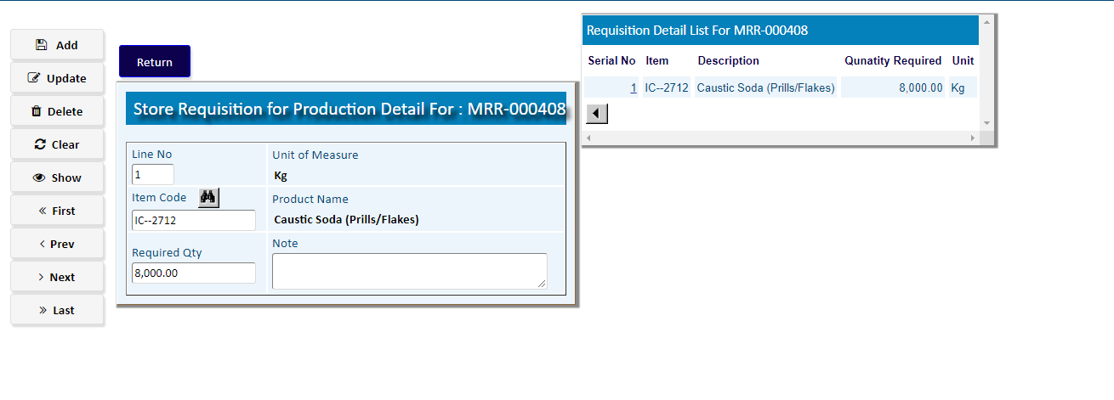

Click **Confirm** to confirm the Bulk Requisition

# Production Process

|  |  |
| --- | --- |
| **Step 1** | Main Menu (Home Icon) **> Production >**  Production Process |
| **Step 2** | Choose **Batch Number ,** & then click **Show** |
| **Step 3** | Click **Start A New Process** to add requisition Items |

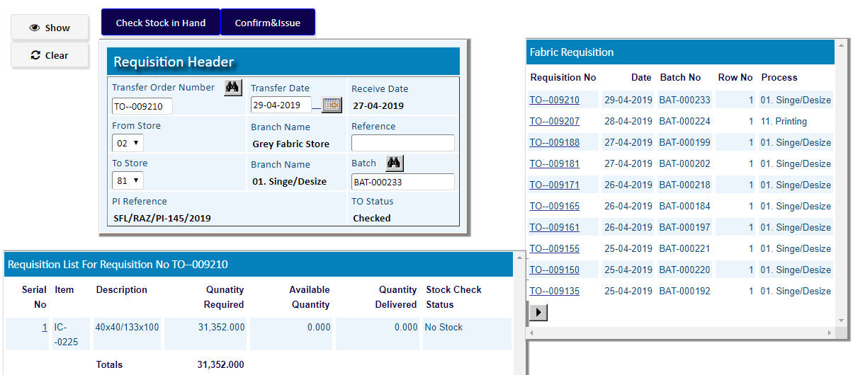

After ending

The all **Production** processes

As per Production Manual,

Go to the option

**INSPECTION FINISHED GOODS**

# Inspection Finished Goods

* Inspection Finished Goods Header

|  |  |
| --- | --- |
| **Step 1** | Main Menu (Home Icon) **> Production >**  **Inspection Finished Goods** |
| **Step 2** | Write Order Number, Reference, From Store, To Store |
| **Step 3** | Click **Add** |
| **Step 4** | to Add Products Click **Detail** |

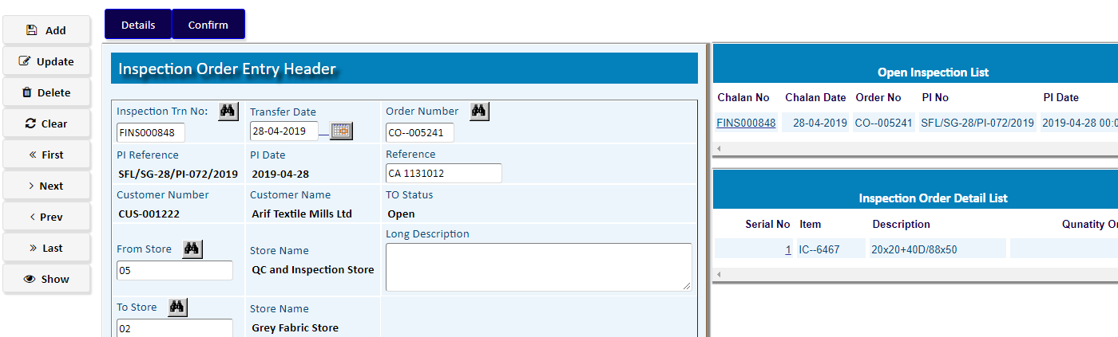

* Inspection Finished Goods Detail

1. Pick a product from the side list of PI Detail
2. Write Qty of Production.
3. Fill the other Info
4. Click **Add**

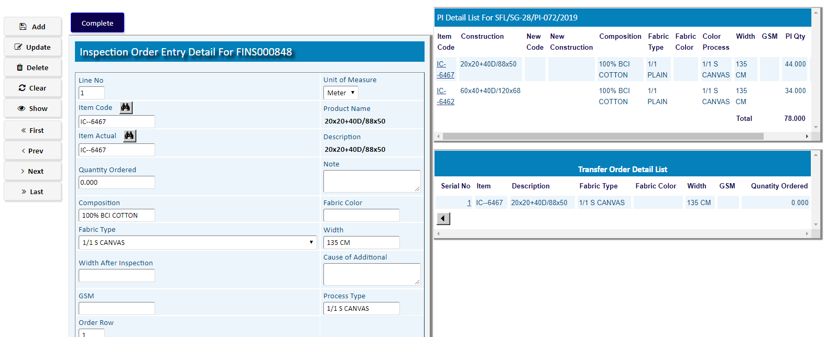

After adding the products, Click **Complete**

To Confirm Click on **Confirm** Button

**Sales Part**

# Order Status

|  |  |
| --- | --- |
| **Step 1** | Main Menu (Home Icon) **>**  **Sales & Delivery > Order Status** |
| **Step 2** | Pick a product from the side list of PI For Approval |
| **Step 3** | Click **Show** and the Click **Approval** |
| **Result** | The Order has been Approved to create Delivery Challan |

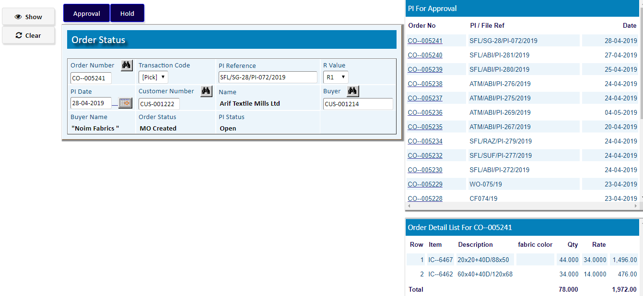

# Delivery Challan Entry

* Delivery Challan Entry Header

|  |  |
| --- | --- |
| **Step 1** | Main Menu (Home Icon) **>**  **Sales & Delivery >**  **Delivery Challan Entry** |
| **Step 2** | Pick a product from the side list of **Order Approved List** |
| **Step 3** | Click **Create DO** |
| **Result** | A new DO will be created & shows on side list of Delivery Order |

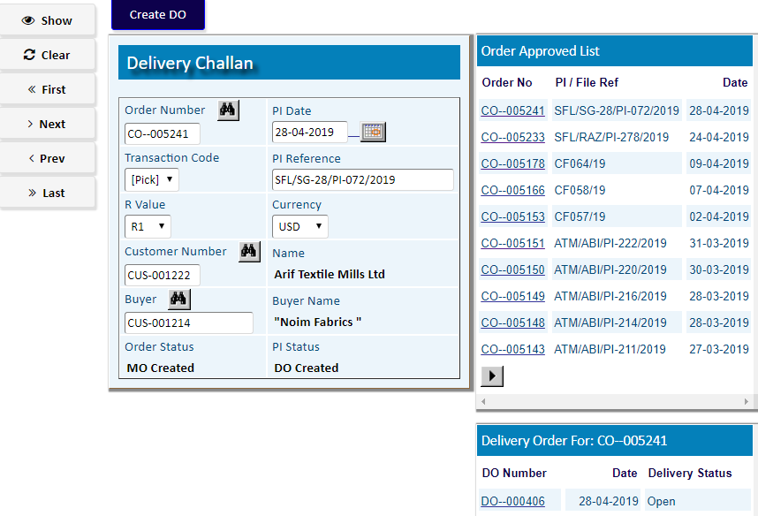

Pick the Created DO Number from the **Delivery Order List** & go to **Delivery Order Header**

* Delivery Order Header

1. Pick a product from the side list of PI Detail
2. Write Store, Reference & Click **Update**
3. Click **Detail** to add Products details

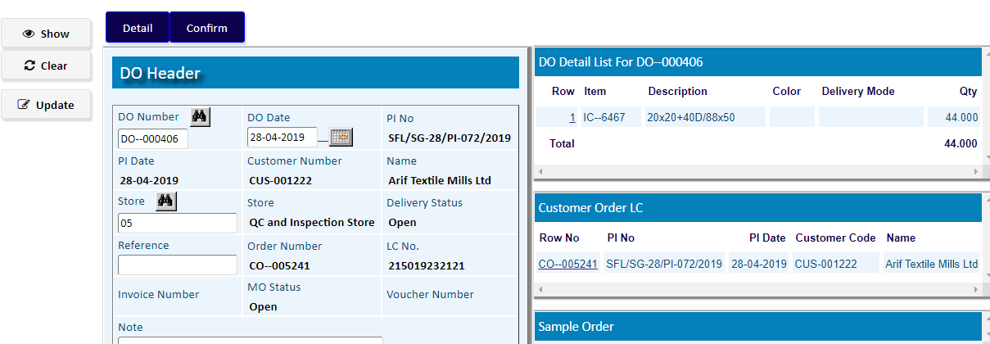

* Delivery Order Detail

1. Pick a product from the side list of PI Detail
2. Write Qty , Rate of Production.
3. Fill the other Info
4. Click **Add**
5. Repeat a to c to add more Items

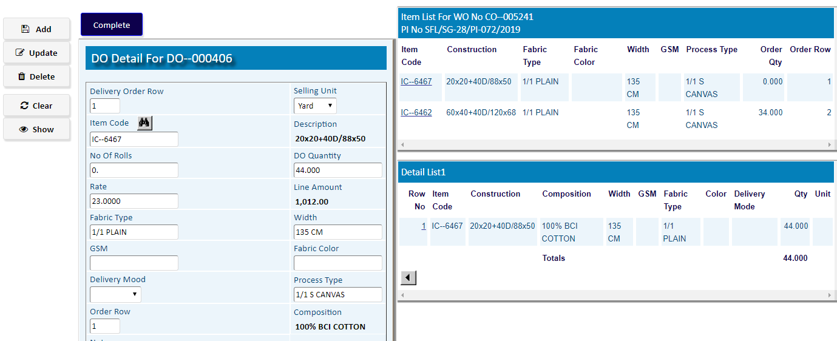

After adding the all products, Click **Complete**

To Confirm Click on **Confirm** Button of **DO Header**

**Commercial Part (CI)**

1. **Commercial Invoice**

* Commercial Invoice Header

|  |  |
| --- | --- |
| **Step 1** | Main Menu (Home Icon) **> Commercial > Export LC >** Commercial Invoice |
| **Step 2** | Write **Invoice Number**, LC No, Date, Buyer etc. |
| **Step 3** | Click **Add** |
| **Result** | A new Commercial Invoice will be Created |

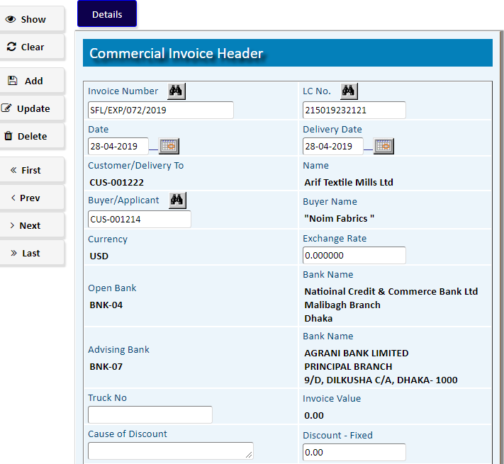

To add nvoice Items Click **Detail**

* Commercial Invoice Detail

1. Pick a product from the side list of PI Detail
2. Write Rate, Quantity Invoiced of Producs.
3. Fill the other Info
4. Click **Add**
5. Repeat a to c to add more Items
6. After adding Items Click **Return**

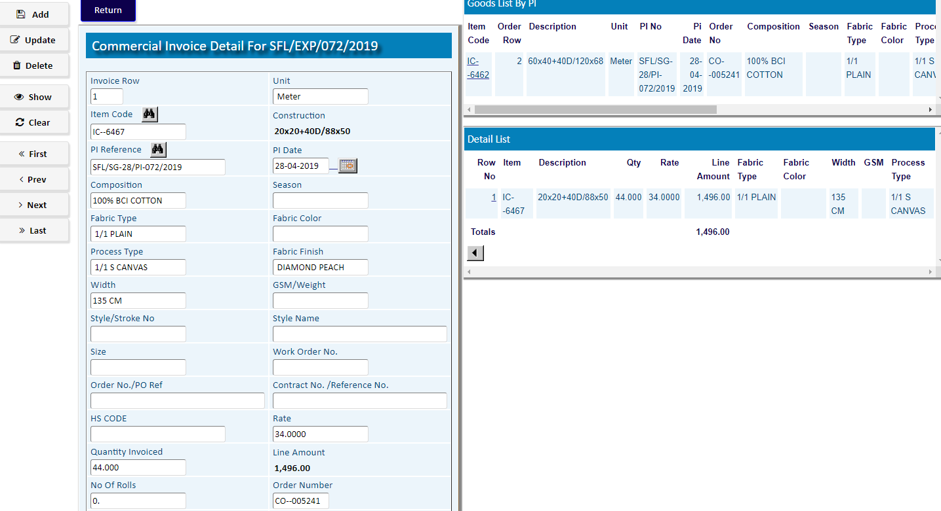

**Accounts Part**

1. **Transfer TO A/R**

|  |  |
| --- | --- |
| **Step 1** | Main Menu (Home Icon) **> Financial Accounts>**  **Accounts Receivable >** Transfer TO A/R |
| **Step 2** | Select an **Invoice Number (CI)** & then click **Show** |
| **Step 4** | If CI No. not linked with DO, then Click on **DO** **Update** button. |

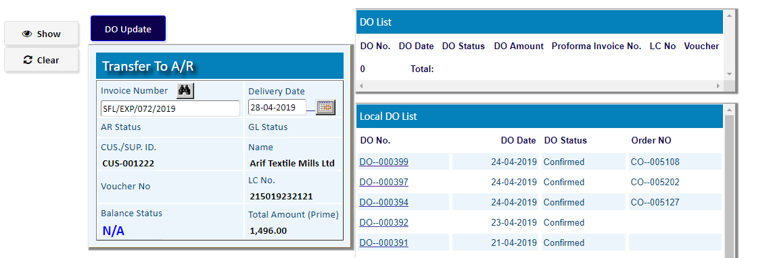

1. Select a DO Number & an Order Number for the DO
2. Click **Save**
3. Click on **Return** button.

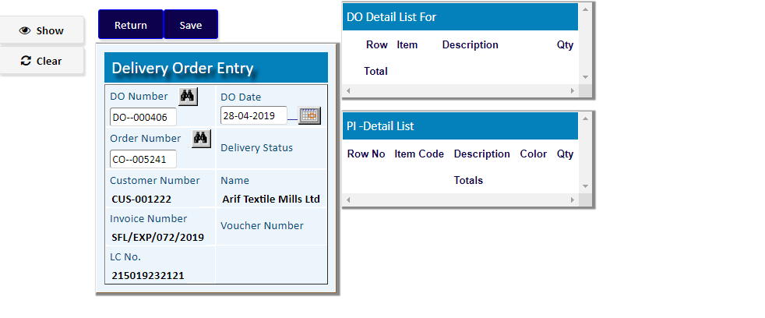

After Clicking on **Return** button of **Delivery Order Entry** screen,

Click on **Transfer To A/R** button to generate a voucher of the DO

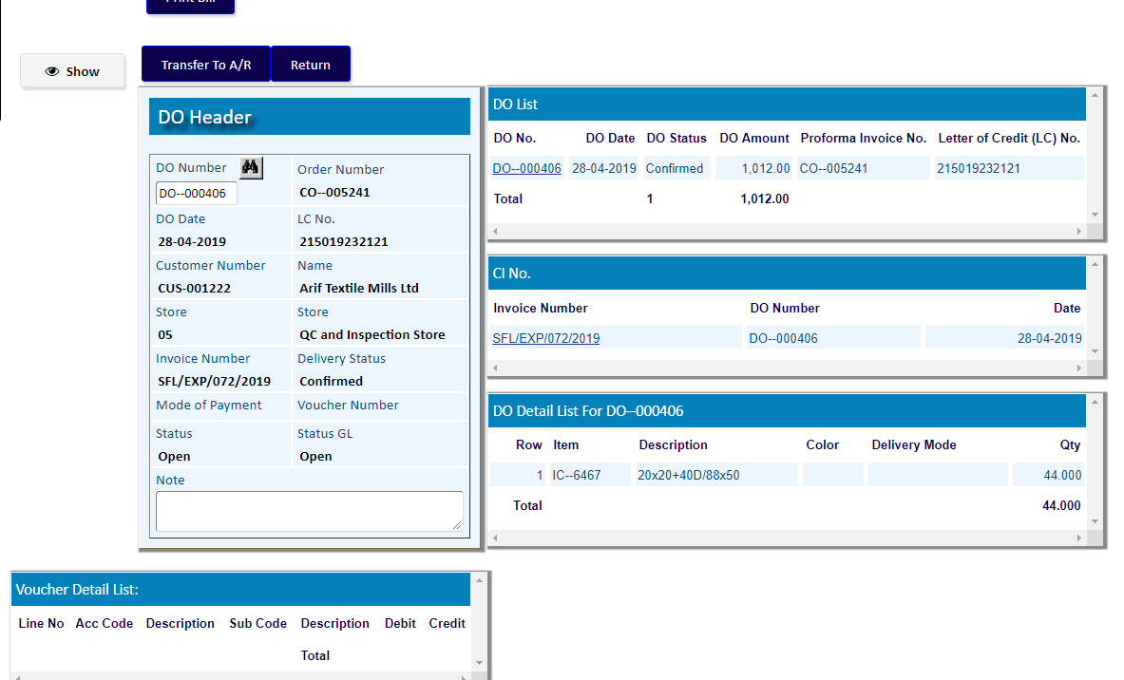

A voucher of the DO has been generated.

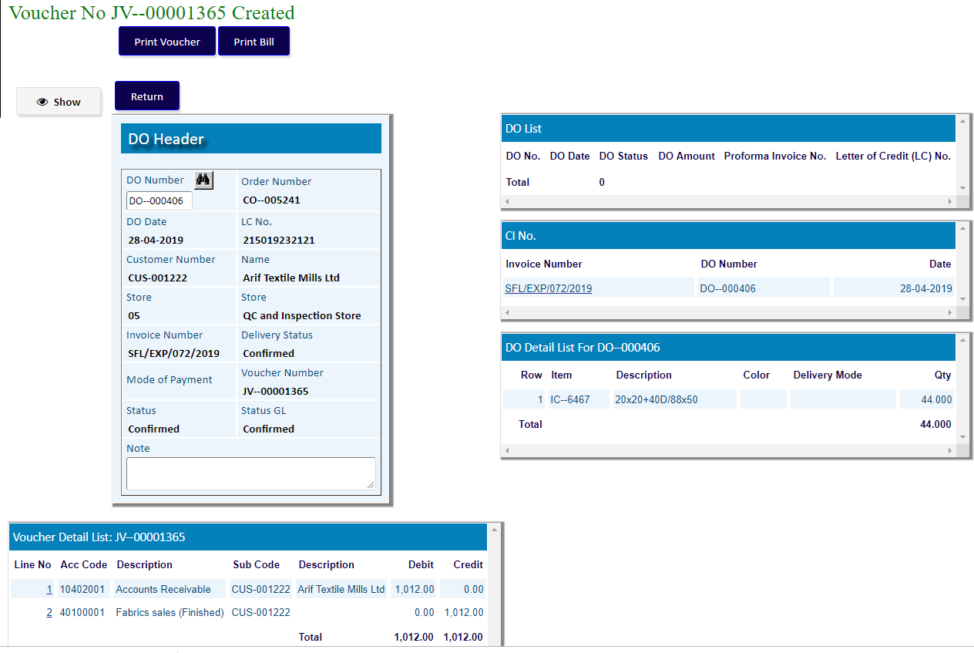

To transfer to A/R For a Local DO :

1. Pick a DO Number from the side list of **Local DO List**

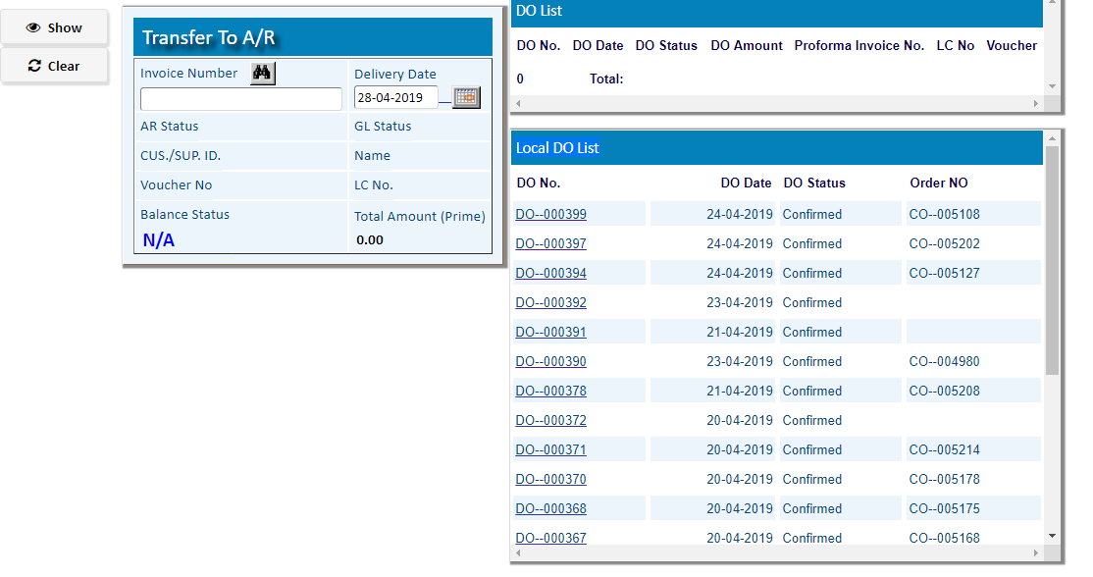

Click on **Transfer To A/R** button to generate a voucher of the DO

